**Uzynagash Secondary school**

**« The use of modern information technologies in teaching English in senior stage of secondary school»**

**Done by:**

**Sarsembayeva Lyubov**

**Uzynagash, 2024**

# CONTENTS

**INTRODUCTION**………………………………………………………….3-4

**CHAPTER 1 THEORETICAL AND METHODOLOGICAL BASIS OF THE USE OF MODERN TECHNOLOGIES IN TEACHING FOREIGN LANGUAGES IN SENIOR STAGE OF SECONDARY SCHOOL**

**1.** Modern information technologies in education………………………….5-6

**1.2** Modern information technologies in teaching foreign languages in senior stage of secondary school……………………………………………………………7-10

**CHAPTER 2 PRACTICAL APPLICATION OF THE USE OF MODERN TECHNOLOGIES IN TEACHING FOREIGN LANGUAGES IN SENIOR STAGE OF SECONDARY SCHOOL**

**2.1.** A set of exercises in English for grades 10-11 using modern information technologies…………………………………………………………………12-40

**CONCLUSION**…………………………………………………………….41

**REFERENCES**…………………………………………………………….42-43

# 

# INTRODUCTION

**The relevance of research:**

The use of modern information technologies for all aspects of our life is becoming more and more obvious every day. It is rather difficult to imagine modern schools without modern computer classes. Modern technologies have become a necessity for us. Recently, the question of the correct use of modern technologies in a specialized school is being raised more and more often. After all, it is not only modern information technologies, it is also a modern approach and methods to the learning process. The purpose of teaching foreign languages is the development of linguistic and cultural competence and the formation of communicative competence among schoolchildren, as well as practical mastery of foreign languages.19]

Possession of communicative competence without being in a foreign country, in a foreign language, is a very difficult task. Therefore, the priority task for the teacher is to create real and fictitious situations, communication in another language, while using various methods of work, such as role-playing games, discussions, creative projects. For this reason, the use of communicative competence and the ways to achieve it is one of the most relevant. Consequently, the relevance of this work is due to the insufficient preparedness of the problem of the use of information technologies in the educational process.

**The object of research:** the process of teaching foreign languages in senior

stage of secondary school using modern information technologies.

**The subject of research:** using the content and methods of teaching a foreign

language using modern information technologies.

**The aim of research:** theoretical proof, preparation and verification of the

methodology using modern technologies in the learning process, aimed at developing the foundations of information, linguistic and communication competence of students.

**The objectives of research:**

-determine the role and place of modern information technologies in education;

-analyze the developed multimedia programs for teaching foreign languages and determine the requirements for them;

- to develop a set of exercises with the use of modern information technologies;

**Methodological base of the research:** Voitko S. A., Zakharova I. G., Polat E.

S., Bukharkina M. Y.

**The leading idea:** the disclosure of individual abilities of each student, the

formation of a personality ready for life in a high-tech and competitive world.

**Methods of research:**

- constructive-critical analysis of the literature on the research problem;

- a research method aimed at selecting programs and sites for learning the language;

**The final product of the research:** Methodical development on the use of

modern information technologies in English lessons for students in grades 10-11

**Practical significance of the research:**

•development of lessons conducted in a senior stage of secondary school using information technologies;

• the possibility of using methodological recommendations when passing pedagogical practice at school.

**The structure of the research:** Introduction, Chapter 1, Chapter 2,

Conclusion, References.

**CHAPTER 1**

**THEORETICAL AND METHODOLOGICAL BASIS OF THE USE OF MODERN TECHNOLOGIES IN TEACHING FOREIGN LANGUAGES IN SENIOR STAGE OF SECONDARY SCHOOL**

**1.1 Modern information technologies in education**

In the Message of N. A. Nazarbayev, " Strategy Kazakhstan-2050”, he states

that we must modernize education and develop online and distance education, by opening modern school centers in the regions and remote areas of our country. We must gradually introduce modern teaching methods, especially online and distance education, which is now accessible to almost everyone.[1]

The use of modern information technologies and the question of their proper

use is an urgent topic today. Learning foreign languages helps to develop students ' communication skills.[12] One of the most important goals of the updated education program is the introduction of criteria-based assessment, which will help to improve the quality of education and pedagogical skills. Not many people know that English is one of the most difficult subjects in school. For this reason, the teacher is faced with the task of increasing interest and motivation in the study of the subject. The main task of the teacher is the ability of the teacher to choose such teaching methods that will increase creative activity and the desire to learn more in the process of learning the language, as well as the teacher should try to organize the educational process so that it is aimed at practical language acquisition.We all know that English is the language of international communication, so knowing English opens up endless possibilities for you. [22]

New information technologies help to create a person-centered approach to

learning, and provide differentiated and individualized learning based on the abilities of children. Educational programs in English lessons include learning vocabulary, improving pronunciation, teaching reading and writing, speech development, and improving grammatical skills.[25]

Time dictates the conditions under which the education system focuses on entering the world information and educational environment. The modern educational environment is faced with a situation where all of us have switched to distance learning. Due to the current situation in the world, we were forced to switch to a format of training that would be safer for the lives of students and teachers. In this regard, the correct use of modern information technologies has become a priority for the entire educational environment.[24]

In the modern educational sphere, changes also relate to changes in the study of

foreign languages in school. During the lesson on learning foreign languages, modern technologies such as the Internet, mobile phones, e-books, computers, interactive whiteboards should be actively used.[18]

Modern information technologies are digital technologies through which we can transmit and distribute various information, such as computers, cell phones, satellites, the Internet, and various multimedia devices. Information technologies of training are all technologies that can be used during training, we also include a computer, various photo and video materials, the Internet, and a mobile phone. [14]

The main pedagogical goals of using modern information technologies in the

educational process [17]

* improving the efficiency and activity of the educational process;

* improve the search for the necessary information using modern technologies

* develop different types of thinking and communication skills;

*formation of skills for making quick decisions in a difficult situation and information culture.

* training of an information-literate person;

* computer training of students ;

Due to the huge impact of modern information technologies on the educational process, many teachers include them in their methodological system.

All means of modern information technologies used in the education system can be divided into two types:[22]

*1) Hardware*

*A computer* is a programmable device that stores, retrieves, and processes data. [2]

*A projector* is a device that helps to visually demonstrate educational material.

*Recording devices* such as a camera, voice recorder, or video camera allow you to display informational images of the surrounding world during training.

*Audio-video tools* provide a more effective communication atmosphere during training.[22]

*2) Software tools:*

*Sources of information* - information on CD-ROMs, information sites and Internet search engines, including those specialized for educational applications.

*Information management* systems support the flow of data between the participants of the educational process: students, teachers, administration, parents, and the public

*Electronic textbook* is a digitized version of course materials that can be read on a computer, e-book reader, or similar device. [3]

Software tools are modern information technologies that are most widely used

in the education system:

1. Training programs

A curriculum is a textbook that helps students do independent work. These textbooks help to activate students, individualize their work and give them the opportunity to independently manage their educational activities. These programs are connected to all the educational material, performing their specific functions.

2. The global Internet

The positive possibility of Internet technologies is the ability to use resources that are sometimes located on the other side of the globe.

Azimov E. G. in the work "Materials of the Internet in English" says: "The mastery of intercultural and communicative processes should not be realized without the practical application of knowledge and the use of the Internet in foreign language lessons. The Internet and modern information technologies help us to communicate independently with foreigners on various interesting topics."

The Internet provides the best opportunities for communication: from traditional email to video conferences and video chats. On this basis, distance education is currently being organized.

3. Distance education

Distance education does not replace, but complements, full-time and part-time education. Distance education is a flexible learning technology that is based on modern information and communication technologies and is considered cost-effective. Distance education is becoming more and more popular. In the modern world, the learning process takes place in conditions of a constant increase in the information received, as it depends on the the correct organization of educational work depends on the professionalism of the teacher.[22]

Doctor of Philosophy, Professor S. S. Kunanbayeva in the" Concept of foreign Language Education of the Republic of Kazakhstan " noted that one of the main directions for improving the training of foreign language teachers is the possession of modern methods and technologies, especially modern information technologies.

The goal of the teacher at the school is to expand knowledge and activity in the

classroom, while learning a foreign language. Innovative methods provide the implementation of a personality-oriented approach, which is aimed at individualization and differentiation of learning while learning a foreign language. These methods include: the design method, which is carried out by using modern information technologies and using the Internet. [21] Modern schoolchildren are those who are interested in absolutely everything, they are interested in learning about travel,communication with foreigners, different cultures and how they differ from us. They expand their horizons and develop mentally, learning a huge number of things about foreign cultures and traditions. [5]

**1.2 Modern information technologies in teaching foreign languages in senior stage of secondary school**

The main goals of using modern information technologies in foreign language

lessons in senior stage of secondary school

* increase motivation and interest in learning English; [23]

* the development of students ' speech competence, which means understanding texts in a foreign language, and the ability to make correct sentences and convey information.

* increase in language skills;

* increase knowledge about the social and cultural characteristics and culture of the country.

* develop the ability and willingness to learn English independently.[24]

Let's consider five main directions of using modern technologies in the classroom (according to **Voitko S. A.):**

1. The use of ready-made multimedia products and computer training systems.

2. Create multimedia and training programs.

3. Create multimedia presentations.

4. The use of modern information technologies in extracurricular activities.

5. Use of Internet.

*1. The use of ready-made multimedia products and computer training systems.*

This direction is one of the most common in the field of teaching English with the help of modern technologies at the senior stage. The number of programs for learning English is much more than simple school textbooks, but the quality of these programs can not be called good. In most cases, they are based on the use of ready-made training courses using multimedia equipment, these training courses consist of exercises to consolidate the material being studied. Computer training programs can be used at all stages of training to develop grammatical, phonetic and lexical skills. However, often most of these programs are ineffective, since almost all types of exercises are reduced only to choosing the correct answer and filling in the missing words. Also, an equally important disadvantage of such programs is the inability to change the content of the program, update the information of educational texts, change or somehow supplement the exercises. Because of this, the full use of computer training programs in teaching English in schools is impossible. Teachers can use only some fragments of programs at some stages of the lessons on several topics that may not always coincide with the material that is in the textbook. Currently, some popular programs in use are "Essential Grammar in Use", "Britannica", "Macmillan English Dictionary", "Bridge to English".

*2. Create multimedia and training programs.*

The computer can store and use a large amount of video materials. In the course of use, this information can be changed, supplemented, changed into a new form, the old material can be replaced with a new one, and the exercises can be information that can be used in educational activities: various texts, exercises, audio and presented in various versions. However, to realize all these advantages of using information technologies at the senior stage, it is necessary to create your own computer training program.The program can be devised by the teacher or prepared in accordance with the educational-methodical complex used in this work. All the components of computer-based training program should meet the objectives of teaching English. In the new teacher program, you need to consider section test the knowledge of students ( for example it can be testing and automatic processing of results) as well as a section of information that displays student work, they read the text, complete the task. Thus, the teacher creates a program for himself and for his students, a program that makes it convenient for him to work, which helps to achieve the goals set and achieve high results in teaching English.Teachers resort to using various software tools to create a training program: HTML editors, Macromedia Flash, Borland Delphi, Visual Basic.

*3. Create multimedia presentations.*

Presentations help to provide students with visual material. Video, audio, and various tables are just a small part of what can be included in the presentation. Animating objects allows, allows students to focus on them. You can use presentations at all stages of the lesson. When learning new words, it is better to use visual materials, they help to clearly demonstrate the necessary material. When studying grammar, you need to highlight complex or important information , for example, when studying the subject and predicate. To consolidate the material, you can use exercises with omissions of the necessary words. Information technologies are a tool for increasing students ' interest in the subjects they study, for example, English. The most popular among teachers and the easiest to use is the Microsoft PowerPoint program, and there are also programs such as Google Presentation. [20]

*4. The use of modern information technologies in extracurricular activities.*

At present, modern information technologies are used not only in traditional lessons, but are also increasingly used in extracurricular activities of students. Most often, this is the preparation of various projects, essays, quizzes, Olympiads, conducting extracurricular activities and games. In the process of working on projects, students often turn to various information resources: electronic encyclopedias, library materials, Internet search engines. When editing, processing information and presenting the results, students work with text and image editors, often performing reports on the work done through presentations or videos. Participation in such projects is very important for students, because in the course of their work they acquire the necessary skills for organizing independent work and research activities.

*5. Use of Internet.*

The Internet is a global information network that includes e-mail, search engines, educational sites and helps to access various information resources, hundreds of social networks. A large amount of information is available on the Internet in English. On the one hand, this makes it necessary to use English when using the Internet, and on the other hand, English enhances the overall cognitive activity of students and increases the motivation to study it.The use of the Internet gives students the opportunity to take part in various international distance Olympiads in English, and other disciplines that are held by various organizations. The number of students in these Olympiads is often unlimited, so all students can try their hand without exception.Also, another direction of using Internet resources is correspondence by e-mail or social networks in the process of learning a foreign language. Correspondence with native speakers in the framework of international communication projects is the best means of developing cross-cultural competence, which is most important in the framework of specialized foreign language training. Correspondence in social networks allows you to establish cross-cultural ties, destroy stereotypes and generally accepted views.[15]

The main types of linguodidactic tasks that can be solved with the help of modern information technologies, linguistic and methodological possibilities of using multimedia teaching tools in mastering aspects of language, forming skills and abilities in various types of speech activity: [4]

*1. Teaching phonetics*

With the help of modern technologies, the technique of visualizing pronunciation is often used. Multimedia technologies help you listen to speech in English, adjust it according to your level of language proficiency, and speed control allows you to break phrases into individual words, which makes it easier to understand words. Using a microphone allows you to customize your phonetic skills.

*2. Teaching grammar*

The use of information technology in grammar lessons in high school is possible when studying any topic. This can be done using diagrams and tables, videos, presentations, and the material will be perceived by students easier and faster. There will also be less time spent on the lesson .

With the use of modern technologies, it has become much more interesting to

monitor the formation of grammatical skills based on test programs and to provide information support to students using various grammatical dictionaries.

*3. Teaching vocabulary*

Test and game programs with the use of visibility, provide information support, such types of work are possible as

* insert spaces in words.

* crossword puzzles

* games for making suggestions.

* "Find a mistake" is an exercise in which you are asked to correct words according to the situation.

*4. Teaching reading*

Modern information technologies allow you to improve your reading skills by using such techniques as:

* consolidation of lexical and grammatical reading skills;

* extraction of semantic information from the text from the main to the secondary.

* text analysis;

* reference and information support

* control of correct understanding[11]

*5. Teaching listening:*

* control of the correct understanding of the listened text.

*6. Learning speaking*

* organization of communication in pairs and small groups using role-playing games

*7. Teaching translation:*

* improve your lexical and grammatical translation skills;

* checking the correctness of the translation;

* rendering reference and information support for such systems as the selection of antonyms and synonyms

The introduction of modern information technologies at the senior stage contributes to the achievement of the main goal of modernizing education – improving the quality of education, increasing the availability of education, ensuring the development of a person who is oriented in the information space, connected to the information and communication capabilities of modern technologies.[13]

**The scheme of lesson planning using ICT.**

|  |  |
| --- | --- |
| **1. The conceptual stage.** | The didactic goal is determined to achieve the following results: formation, consolidation, improvement of knowledge; formation of skills. Electronic educational resources of a specific methodological purpose are selected: training, search, simulation, demonstration, modeling, monitoring, and educational-game resources.[13] |
| **2. Technological stage.** | The form of the foreign language lesson is selected . In addition, a more detailed analysis of the electronic resource is being carried out. At this stage, the necessary hardware and software (multimedia computer, software tools) are determined.[13] |
| **3. Operational stage.** | The main structural elements of the lesson are highlighted, the methods of interaction of various components and their functional relationships are selected. Step-by-step lesson planning is carried out, for each of its stages, the purpose, duration, form of organization of students ' activities, the functions of the teacher and the main types of his activities, the form of intermediate control are determined.[13] |
| **4.Pedagogical implementation.** | Translation of pedagogical principles into specific learning effects. Determining the current psychological state and level of knowledge of the trainees. Planning and implementing the optimal sequence of actions that ensures the assimilation of the necessary knowledge in the shortest possible time . At this stage of the lesson, related to the use of information technology tools, the teacher mainly provides individual control over the work of students. [13] |

**CHAPTER 2**

**PRACTICAL APPLICATION OF THE USE OF MODERN TECHNOLOGIES IN TEACHING FOREIGN LANGUAGES IN SENIOR STAGE OF SECONDARY SCHOOL**

**2.1 A set of exercises in English for grades 10-11 using modern information communication technologies**

**Theme:** Nanotechnology

**Grade:** 10

**VOCABULARY**

**Learning new words using the site :**<https://quizlet.com/_9ohujb?x=1jqt&i=2ci0qw>

**Nanotechnology** - the branch of technology that deals with things smaller than 100 nanometers.

**Atom -** the smallest particle of the element

**Sunscreen-** partial block against cancer-causing sun rays

**Tiny** - extremely small

**Transparent**- Allowing light to pass through

**Rust** - formation of reddish-brown iron oxides on iron during low-temperature oxidation in the presence of water

**Inject** - squeeze into something; squeeze in liquid

**Coat** - cover the food thoroughly with a liquid or dry mixture

**Nanometre** - one billionth of a metre

**Manufacturers** - businesses that turn raw materials or processed goods into finished products

**Equally** - to the same extent or at the same level; in quantities or parts that are of the same size

**Harm** - to damage

**Reflection** - the rebound of a beam of light, sound, or heat when the beam hits a surface through which it does not pass



**LISTENING**

Task 1.Watch the video. What is the video about? What is nanotechnology and what is it used for?

**Video:** [**https://www.youtube.com/watch?v=dQhhcgn8YZo**](https://www.youtube.com/watch?v=dQhhcgn8YZo)

**Transcription:** Today, we are going to talk about nanotechnology. When we say something is nano, we mean it is very small. The size of one nanometer is one billionth of a meter, which is about 100.000 times smaller than the width of a human hair. Making new things at this incredibly small scale is called nanotechnology, and it's one of the most exciting and fast moving areas of science today. Some nanomaterials are naturally occurring you can find them everywhere in volcanic ash, ocean spray, fine sand and dust. Naturally occurring nanostructures are also present in plants and animals. For example, nanostructures in insect eyes ensure an anti-reflection and water repelling effect so they can fly safely. Nowadays, scientists can create nanostructures themselves by rearranging the atoms of an object. They can make new nanomaterial with new properties. For example, that are stronger, lighter or different in color. The properties change also according to their size, and this is the magic of the technology. In the food area researchers are working with nanotechnology to create novel products that may be of benefit to health and diets. For example, nanosilver has antibacterial properties that can be used in food contact material such as cutting boards. In food supplements nanosized carriers increase absorption of nutrients.Nanosensors can be incorporated into packaging to monitor the quality and shelf life of food from manufacturers to consumers. It can also make food ingredients tastier or healthier. Carving up a grain of salt into small, nanosized grains increases its surface area significantly. This means that your food needs far less salt to be equally tasty. This is good news for those who like crackers but are worried about their blood pressure. We need to make sure that food nanotechnologies do not cause harm to consumers. This is why, in the EU, engineered nanomaterials in food require a safety assessment. Their specific properties need to be taken into account when assessing impacts on human health and the environment. And this is where EFSA comes in. Over the coming years, nanotechnology will touch the lives of all of us. Like many scientific advances, it brings uncertainty and potential risks. It is up to scientists, business and governments to make it work.

**Task 2. Watch the video and decide if sentences are True or False.**

1. The size of one nanometer is one millionth of a meter.
2. Scientists can create their own nanostructures.
3. Nanomaterials can't change.
4. In the food field, researchers are working with nanotechnology
5. Creating new things on an incredibly small scale is called nanotechnology.
6. Nanosilver does not have antibacterial properties
7. In the near future, nanotechnology will touch the lives of all of us.
8. Natural nanostructures are present in plants and animals.

**Answer keys :**

1.F

2.T

3.F

4.T

5.T

6.F

7.T

8.T

**READING**

**Task 3. Read the text and answer the questions below.**

[**https://docs.google.com/forms/d/e/1FAIpQLSdBMvOPAH31dOqw664-kGcUIW6zVy7d2QlPnT0EeKRli3xm7g/viewform**](https://docs.google.com/forms/d/e/1FAIpQLSdBMvOPAH31dOqw664-kGcUIW6zVy7d2QlPnT0EeKRli3xm7g/viewform)

**What is nanotechnology?**

Nanotechnology, shortened to “nanotech”, is the study of the controlling of

matter on an atomic and molecular scale. Nanotechnology deals with structures of

the size 100 nanometers or smaller in at least one dimension, and involves developing materials or devices within that size. Nanostructures are assembled a single

atom, molecule, or atomic layer at a time, as part of a vast new field of research in

nanomaterials synthesis and assembly. In other words it is the engineering of functional systems at molecular scale. It offers ways to create smaller, cheaper, lighter and faster devices that can do more and cleverer things, use less raw materials and consume less energy. Nanotechnology originates from the Greek word meaning “dwarf”. “Nano” is a prefix meaning one-billionth. A nanometer is one-billionth of a meter or it is about one hundred thousandth of the width of a hair! The world of atoms and molecules could not be visualized and managed until a new generation of microscopes were invented in 1980s in IBM in Switzerland. Generally, structures smaller than a nanometer tend to behave much like individual atoms, while materials that are hundreds of nanometers or greater in size exhibit properties of the continum.Nanoscale properties and behaviors can be quite different as the result of unique physical and chemical interactions. The preponderance of surfaces and interfaces, and the physical confinement of matter and energy, can alter nearly all properties of materials (physical, chemical, optical, etc.), and thus produce extraordinary new behaviors. Examples include generating light from dark materials, improving efficiencies of catalysts by orders of magnitude, and turning soft and ductile materials like gold into solids with hardness equivalent to bearing steel. The final ingredient to nanotechnology is the ability to characterize and predict nanoscale properties and behavior. New experimental tools that are able to “see”, “touch”, and measure the behavior of individual nanostructures allow scientists and engineers to identify subtle differences in structure and properties that control nanoscale properties. By coupling new experimental techniques with advanced computational tools, researchers can develop, verify, and refine models and simulations that will allow the full potential for nanotechnology to be explored. There has been much debate on the future implications of nanotechnology. Nanotechnology has the potential to create many new materials and devices with a vast range of applications, such as in medicine, electronics and energy production. On the other hand, nanotechnology raises many of the same issues as with any introduction of new technology, including concerns about the toxicity and environmental impact of nanomaterials, and their potential effects on global economics, as well as speculation about various doomsday scenarios. These concerns have led to a debate among advocacy groups and governments on whether special regulation of nanotechnology is warranted. [6]

Source: <https://studfiles.net/preview/2968310/>

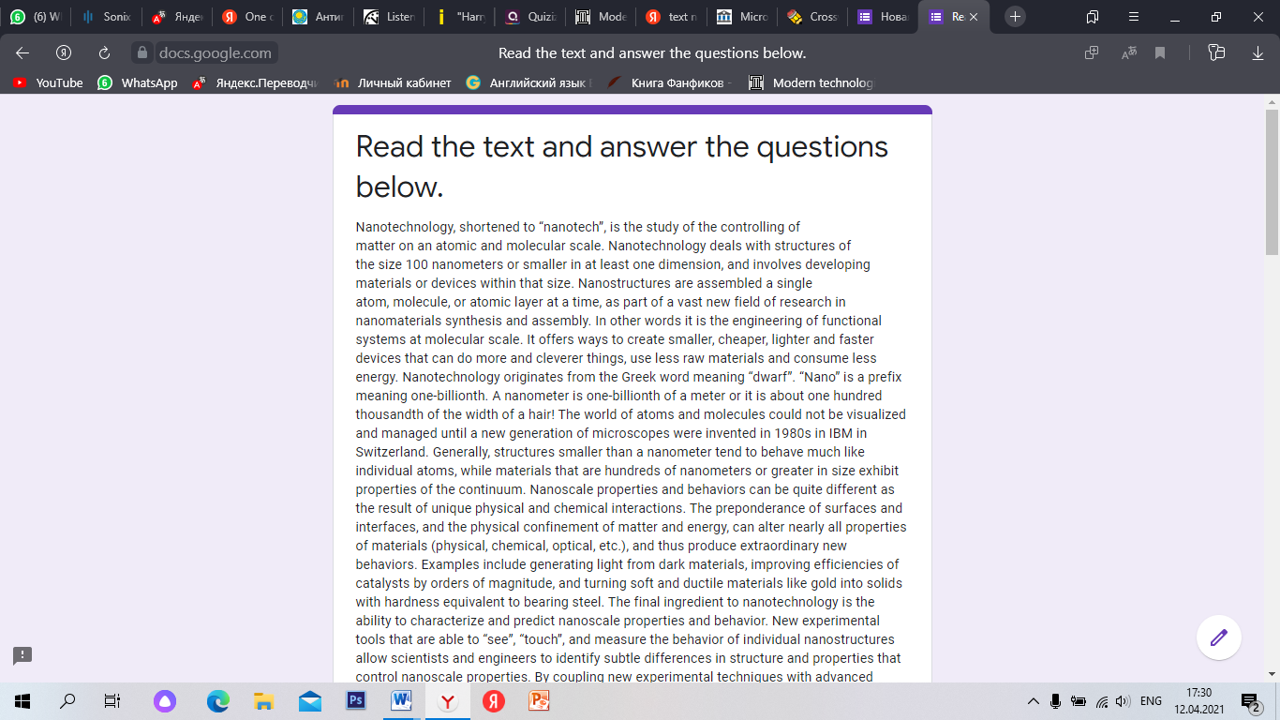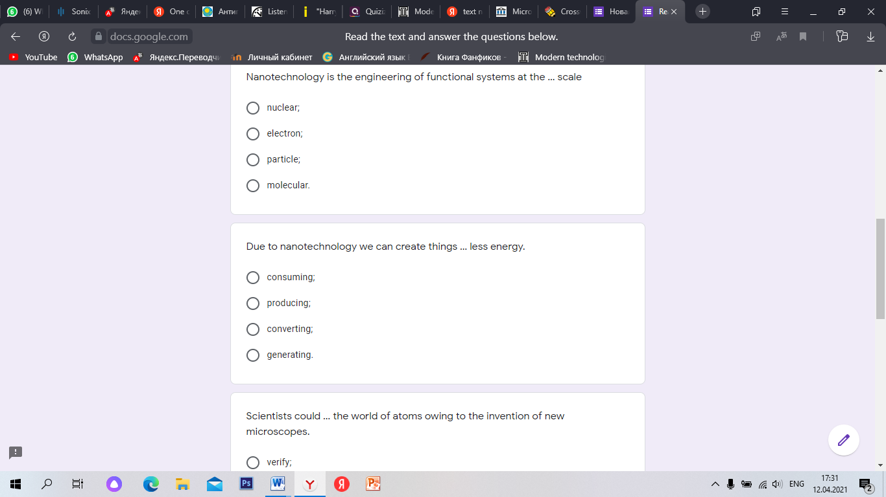

**Task 4. Insert the necessary word in the gap.**

1) Nanotechnology is the engineering of functional systems at the … scale.

a) nuclear;

b) electron;

c) particle;

d) molecular.

2) Due to nanotechnology we can create things … less energy.

a) consuming;

b) producing;

c) converting;

d) generating.

3) Scientists could … the world of atoms owing to the invention of new microscopes.

a) verify;

b) offer;

c) visualize;

d) penetrate.

4) New … of microscopes helped advance the science of nanotechnology.

a) gravitation;

b) generation;

c) production;

d) contribution.

5) The science of nanotechnology attracted attention of scientists all over the

world … its limitless possibilities.

a) in spite of;

b) because of;

c) instead of;

d) due to.

**Answer keys :**

1.D

2.A

3.C

4.D

5.A

**SPEAKING**

**Task 5. Nanotechnology promises to completely eliminate several major diseases, such as cancer and heart disease. What does this mean for the modern world? In small groups, discuss, search for information on the Internet, and then prepare a presentation on one of these topics and present it to the class:**

If people did not die from diseases, the population of our world would grow rapidly. What impact would this have on the global economy ? Would the authorities be able to support such a large population? Or will we have to move people into space?

What would be a typical day in the life of a doctor if diseases disappeared or were almost instantly diagnosed and cured.How would you spend your working day? Imagine what conditions would be left for you to treat?

**Theme:** Natural Disasters

**Grade:** 10

**VOCABULARY**

***Learning new words using the site***

[**https://quizlet.com/_9ojpwl?x=1qqt&i=2ci0qw**](https://quizlet.com/_9ojpwl?x=1qqt&i=2ci0qw)

**Thunder** - sudden loud noise from the sky especially during a thunderstorm

**Lightning** - a flash of bright light in the sky that is produced by electricity moving between clouds or from clouds to the ground.;

**Cyclone** - a strong tropical storm or wind in which the air moves very quickly in a circular direction;

**Storm** - extreme weather conditions with very strong winds, heavy rain and often thunder and lightning;

**Charge** - to put electricity into an electrical device such as a battery;

**Damage** - harm or ruin something;

**Induce** - to make something happen;

**Thunderstorm** - thunderstorms with thunder and lightning and usually heavy rain;

**Cause** - for something to happen, especially something bad;

**Blizzard** - severe snow storm with strong winds;

**Typhoon** - a strong wind with a circular motion is found in the western Pacific Ocean;

**Extreme** - very large number or degree;

**Clockwise** - in the direction in which the arrows of the aces move;

**Interplay** - the effect that two or more things have on each other;

**Wildfire** - a fire that burns strongly and uncontrollably on a patch of grass or shrubbery in a rural area.

**Test :<https://quizlet.com/585426405/test>**

**Task 1. Write the correct answer.**

1. severe snow storm with strong winds;

___________________________________

2. harm or ruin something

___________________________________  
3.a fire that burns strongly and uncontrollably on a patch of grass or shrubbery in a rural area.

___________________________________

4.a strong tropical storm or wind in which the air moves very quickly in a circular direction;

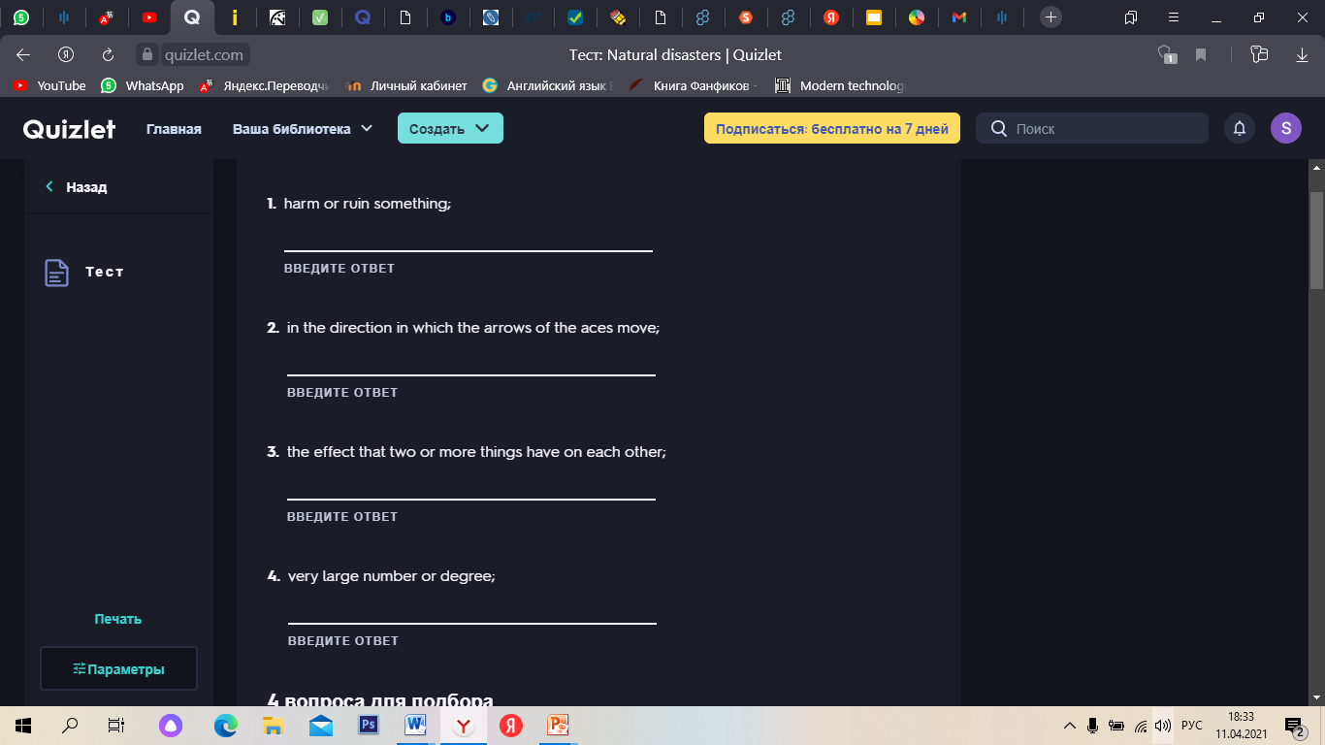

**Answer Keys.**

1. Blizzard
2. Damage
3. Wildlife
4. Extreme

**Task 2. Choose the correct letter for each sentence.**

A.Thunderstorm

B.Charge

C.Typhoon

D.Thunder

1.sudden loud noise from the sky especially during a thunderstorm ___

2. to put electricity into an electrical device such as a battery; ___

3. thunderstorms with thunder and lightning and usually heavy rain; ___

4. a strong wind with a circular motion is found in the western Pacific Ocean; ___

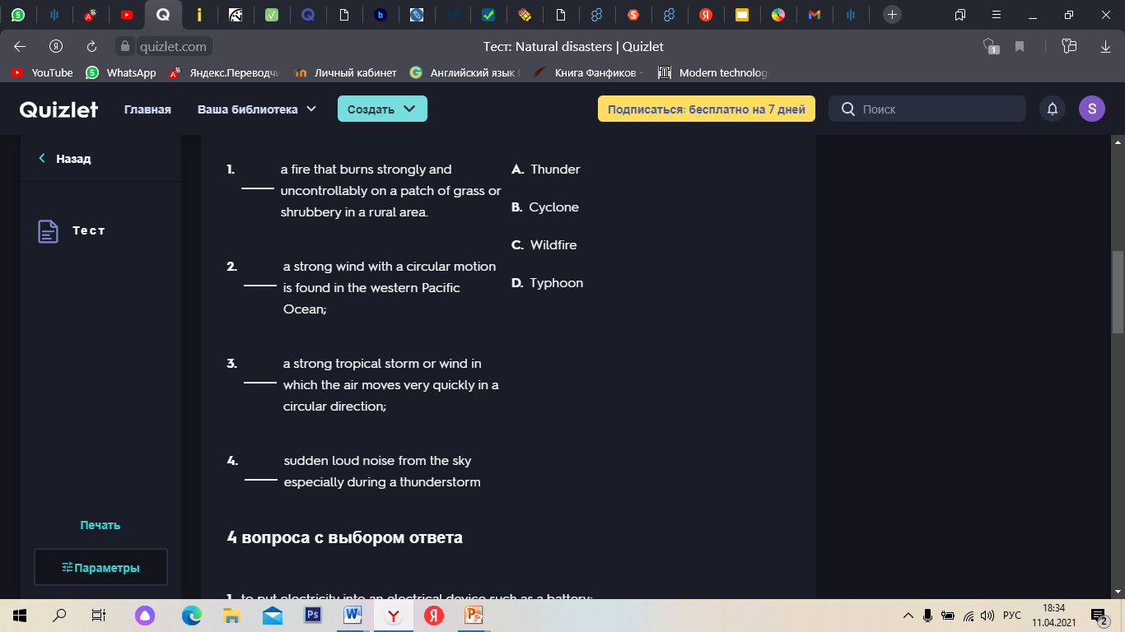

**Answer Keys:**

1.C

2.D

3.A

4.B

**Task 3. Choose the correct answer.**

1. The effect that two or more things have on each other;

A. Thunder

B. Clockwise

C. Interplay

D. Thunderstorm

2. For something to happen, especially something bad.

A. Cause

B. Damage

C. Charge

D. Induce

3. Very large number or degree.

A. Blizzard

B. Damage

C. Induce

D. Extreme

4. A flash of bright light in the sky that is produced by electricity moving between clouds or from clouds to the ground.

A. Lightning

B. Wildlife

C. Clockwise

D. Cyclone

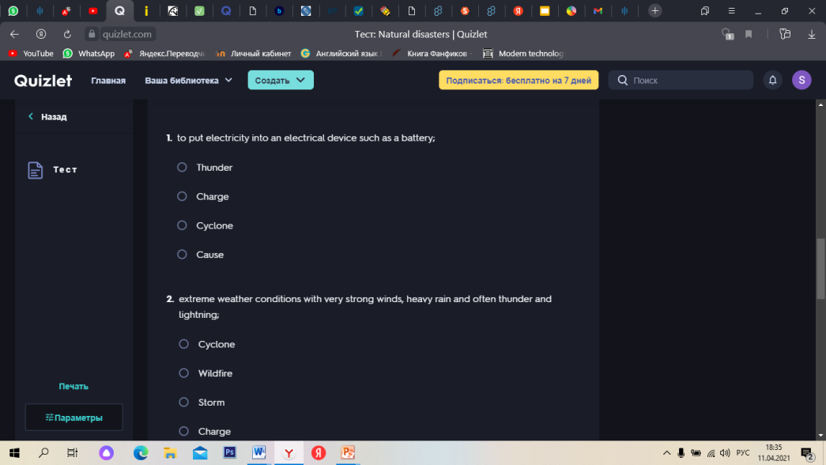

**Answer Keys:**

1.Interplay

2.Cause

3.Blizzard

4.Lightning

**Task 4. Decide if sentences are True or False.**

1.To make something happen → ***Induce***

2.Extreme weather conditions with very strong winds, heavy rain and often thunder and lightning → ***Cyclone***

3.In the direction in which the arrows of the aces move → ***Interplay***

**Answer Keys:**

1.T

2.F

3.F

**WRITING**

**Task 5.Performing exercises on the :**

[***https://www.liveworksheets.com/myworkbooks/preview.asp?workbookid=1032226&clave=4slygbpu***](https://www.liveworksheets.com/myworkbooks/preview.asp?workbookid=1032226&clave=4slygbpu)

**1. Match the words with their definitions.**

1. a flood

2. a wildfire

3. an earthquake

4. an avalanche

5. a drought

6. a hurricane

a. a spreading fire that is difficult to bring under control

b. a large amount of water covering an area

c. a violent wind which has a circular movement

d. a long period when there is little or no rain

e. a sudden violent movement of the Earth’s surface

f. a large amount of snow falling quickly down a mountain

**2. Fill in the sentences with the words below.**

1. The ………….spread through the country and burnt some areas of forest.

2. If there is a lot of rain, ………… can happen.

3. It will take several hours to dig people out of the snow from the……………………..

4. An extremely violent ………passed over the island, destroying the fruit-trees in the islands orchards.

5. This city was completely destroyed by a great ………..on the 28th of October 1746.

6. High temperatures and …………..have continued for more than three weeks.

**3. Choose the correct form of the passive present perfect form.**

1. We………………………about natural disasters by someone.

2. Some men and women ..……………..by a helicopter.

3. New houses…………………..after the earthquake.

4. The famine situation in Asia and Africa………………… by the United Nations.

5. African children suffering from malnutrition ………………by some European families.

**4. Choose the correct word.**

1. If there is a risk of an earthquake, you are not allowed to /supposed to run outside.

2. If your clothes catch fire, you are allowed to / supposed to stop, drop and roll.

3. Your children are allowed to / supposed to crawl under the table during an earthquake to stay safe.

4. Herders are allowed to / supposed to prepare well for natural disasters in summer.

5. People are supposed to / allowed to stay low when escaping a fire.

6. When there is a small fire you have to / don’t have to use a fire extinguisher.

7. You have to / has to stay at home during a winter storm.

8. During thunderstorms, people must / have to avoid standing near tall trees.

**5. Listening exercise.**

Listen to the talk and choose a or b.

a. Nomin is talking about the situation

b. Nomin is asking about the situation.

**Listen again and choose the correct answer.**

1. She talks about………………

A) kinds of different weather

B) the dangers of weather

2. The phenomenon is…………

A) unusual in Mongolia

B) usual in Mongolia

3. Mongolia is having ……….weather.

A) wonderful

B) extreme

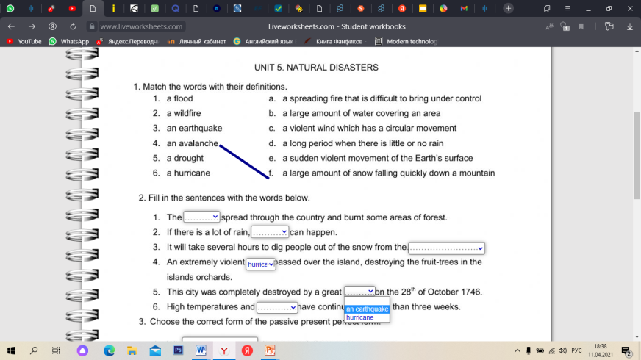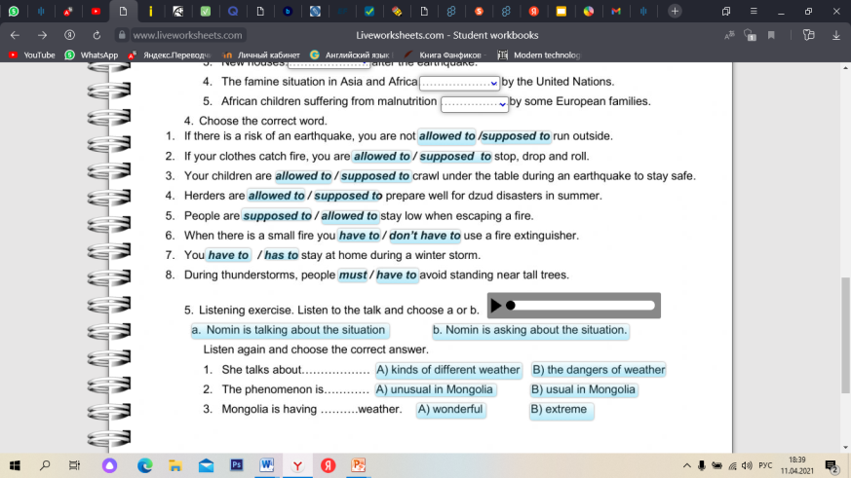

**Listening transcription :**Hi, everyone. This is Nomin from Mongolia . And the question that I have to answer now is about whether you have noticed climate change in your country. Well, yes, sadly, we have recently been experiencing some very big thunderstorms, very shocking thunderstorms that have hurt people and that kind of phenomenon that is not that common in this country. It means that we should be very careful in summertime during the rainy periods. For example, we aren't supposed to use cell phones when there's a thunderstorm. So you can switch off our mobile phones if we think lightning may strike. Yes, I would say that we're having more extreme climate here in Mongolia where the kinds of weather we are seeing can be unexpected.

**Answer Keys:**

1.

1.b

2.a

3.e

4.f

5.d

6.c

2.

Wildlife

Flood

Avalanche

Hurricane

An earth

Drought

3.

Have been told

Have been rescued

Have built

Have been announced

Have been suffered

4.

Allowed to

Supposed to

Supposed to

Supposed to

Supposed to

Allowed to

Have to

Have to

Have to

5.

A

B

A

**SPEAKING**

**Task 6.Find more information in the Internet and continue the sentence: One of the most devastating natural disasters is ....**

**Be ready to speak about 3 minutes.**

**Theme:** Robotics

**Grade:** 11

**READING**

**Task 1.Read the text. What do you know about Robotics?**

**https://www.canva.com/design/DAEbckwl8X4/0sqwRi3wHlD-qRgZDOHs7A/view?utm_content=DAEbckwl8X4&utm_campaign=designshare&utm_medium=link&utm_source=publishsharelink**

**What Is Robotics?**

Robotics is the intersection of science, engineering and technology that produces machines, called robots, that substitute for human actions. Robots are gaining intellectual and mechanical capabilities that don’t put the possibility of a R2-D2-like machine out of reach in the future. As technology progresses, so too does the scope of what is considered robotics. In 2005, 90% of all robots could be found assembling cars in automotive factories. These robots consist mainly of mechanical arms tasked with welding or screwing on certain parts of a car. Today, we’re seeing an evolved and expanded definition of robotics that includes the development, creation and use of bots that explore Earth’s harshest conditions, robots that assist law-enforcement and even robots that assist in almost every facet of healthcare.

While the overall world of robotics is expanding, a robot has some consistent characteristics:

1.Robots all consist of some sort of mechanical construction. The mechanical aspect of a robot helps it complete tasks in the environment for which it’s designed. For example, the Mars 2020 Rover’s wheels are individually motorized and made of titanium tubing that help it firmly grip the harsh terrain of the red planet.

2.Robots need electrical components that control and power the machinery. Essentially, an electric current (a battery, for example) is needed to power a large majority of robots.

3.Robots contain at least some level of computer programming. Without a set of code telling it what to do, a robot would just be another piece of simple machinery. Inserting a program into a robot gives it the ability to know when and how to carry out a task.

The robotics industry is still relatively young, but has already made amazing strides. From the deepest depths of our oceans to the highest heights of outer space, robots can be found performing tasks that humans couldn’t dream of achieving.[7]

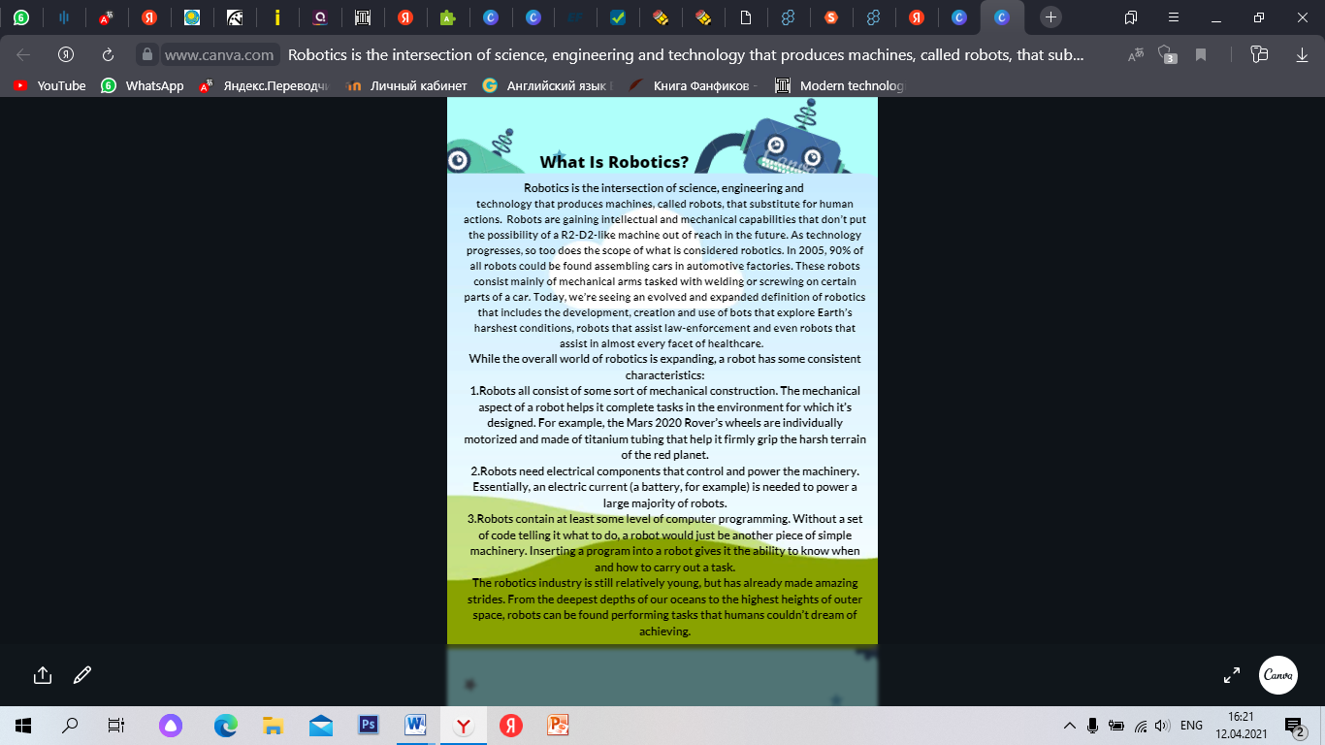

**Task 2. Decide if sentences are True or False.**

Performing an exercise using the site. The wheel turns, stops at any sentence, the student answers whether the sentence is True or False.

[**https://wheeldecide.com/index.php?c1=1.+Robotics+is+the+intersection+of+science+and+technology+that+produce+robots.&c2=2.+Not+all+robots+have+a+mechanical+design.&c3=3.+Robots+need+electrical+components&c4=4.+Electric+current+is+necessary+for+most+robots.&c5=5.+Robots+cannot+be+used+to+study+the+conditions+of+the+Earth,+to+help+law+enforcement+agencies.&t=Decide+if+sentences+are+True+or+False.&time=5**](https://wheeldecide.com/index.php?c1=1.+Robotics+is+the+intersection+of+science+and+technology+that+produce+robots.&c2=2.+Not+all+robots+have+a+mechanical+design.&c3=3.+Robots+need+electrical+components&c4=4.+Electric+current+is+necessary+for+most+robots.&c5=5.+Robots+cannot+be+used+to+study+the+conditions+of+the+Earth,+to+help+law+enforcement+agencies.&t=Decide+if+sentences+are+True+or+False.&time=5)

1.Robotics is the intersection of science and technology that produce robots.

2. Not all robots have a mechanical design.

3. Robots need electrical components

4. Electric current is necessary for most robots.

5. Robots cannot be used to study the conditions of the Earth, to help law enforcement agencies.

6. Robots replace human actions

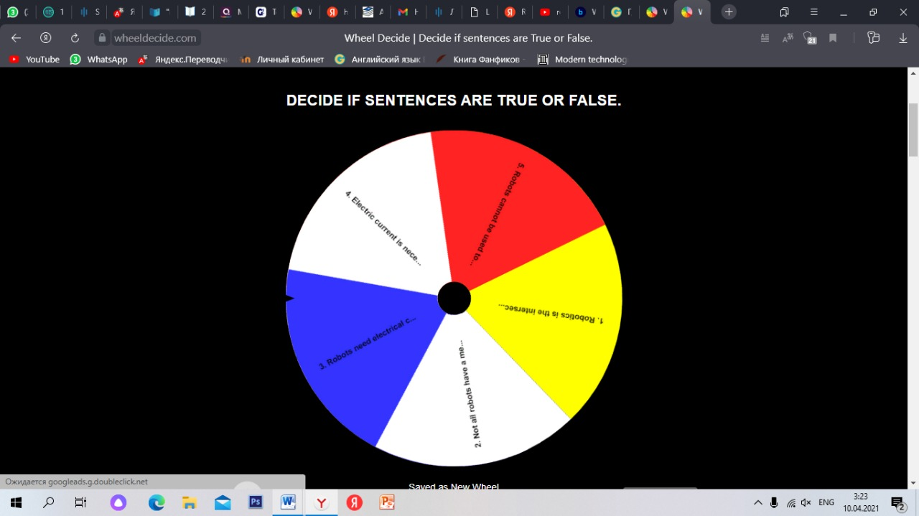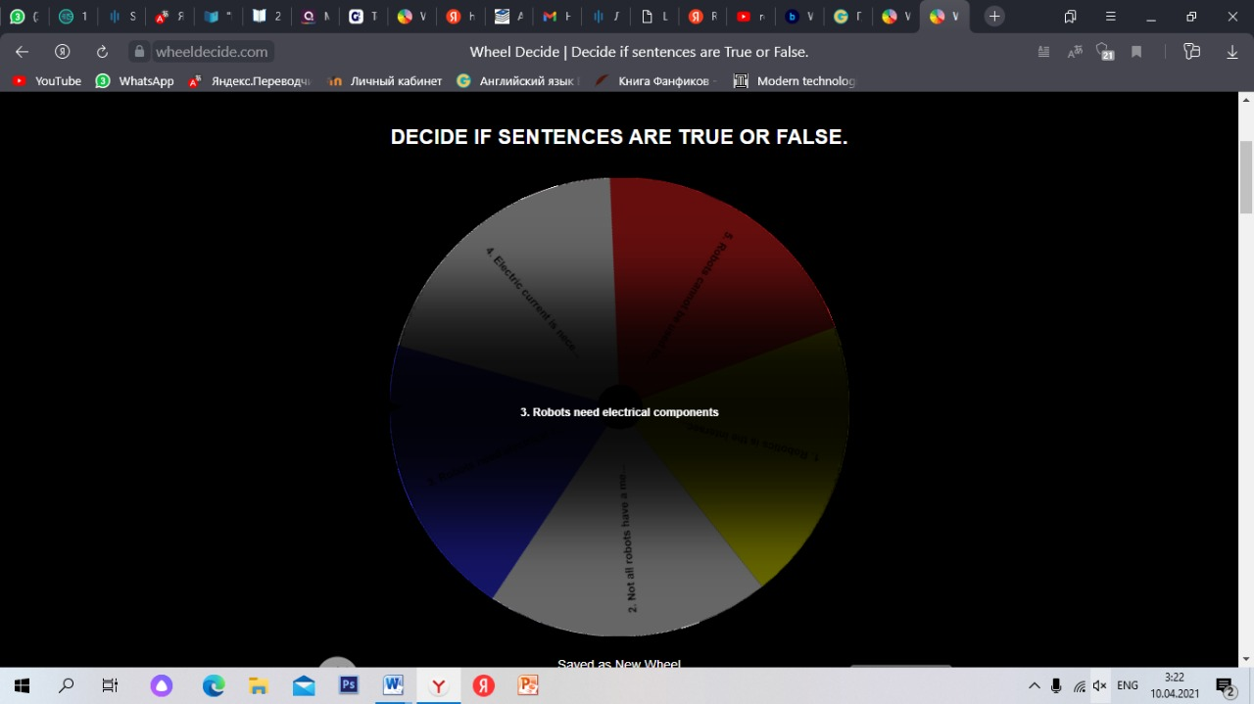

**Answer Keys:**

1.T

2.F

3.T

4.T

5.F

6.T

**Task3.Read the text about the types of robots. How many types of robots are there? Why are robots important in our lives?**

https://www.canva.com/design/DAEbNd21BYs/Qbk5_9ISNjB_5aHRDNJezg/view?utm_content=DAEbNd21BYs&utm_campaign=designshare&utm_medium=link&utm_source=publishsharelink

**Types of Robots**Mechanical bots come in all shapes and sizes to efficiently carry out the task for which they are designed. From the 0.2 millimeter-long “RoboBee” to the 200 meter-long robotic shipping vessel “Vindskip,” robots are emerging to carry out tasks that humans simply can’t. Generally, there are five types of robots:

Pre-Programmed Robots

Pre-programmed robots operate in a controlled environment where they do simple, monotonous tasks. An example of a pre-programmed robot would be a mechanical arm on an automotive assembly line. The arm serves one function — to weld a door on, to insert a certain part into the engine, etc. — and it's job is to perform that task longer, faster and more efficiently than a human.  
Humanoid Robots

Humanoid robots are robots that look like and/or mimic human behavior. These robots usually perform human-like activities (like running, jumping and carrying objects), and are sometimes designed to look like us, even having human faces and expressions. Two of the most prominent examples of humanoid robots are [Hanson Robotics’ Sophia](https://www.hansonrobotics.com/sophia/) (in the video above) and Boston Dynamics’ [Atlas](https://www.bostondynamics.com/atlas).

Autonomous Robots

Autonomous robots operate independently of human operators. These robots are usually designed to carry out tasks in open environments that do not require human supervision. An example of an autonomous robot would be the Roomba vacuum cleaner, which uses sensors to roam throughout a home freely.

Teleoperated Robots

Teleoperated robots are mechanical bots controlled by humans. These robots usually work in extreme geographical conditions, weather, circumstances, etc. Examples of teleoperated robots are the human-controlled submarines used to fix underwater pipe leaks during the BP oil spill or [drones used to detect landmines](https://builtin.com/robotics/landmine-detecting-drones-could-help-save-lives) on a battlefield.  
Augmenting Robots

Augmenting robots either enhance current human capabilities or replace the capabilities a human may have lost. Some examples of augmenting robots are robotic prosthetic limbs or exoskeletons used to lift hefty weights.[7]

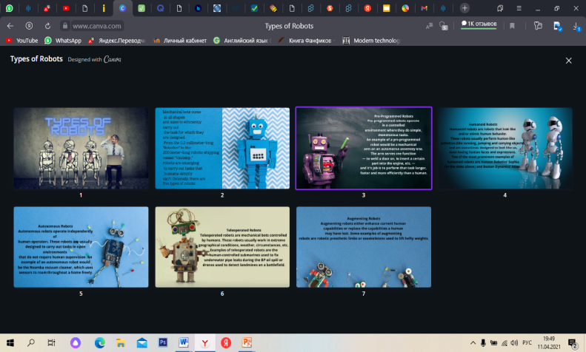

**Task 4 . Choose the correct option.**

***Performing a test on the site .***

[**https://quizizz.com/join/quiz/6070c7fa36f02d001b0ec965/start?studentShare=true**](https://quizizz.com/join/quiz/6070c7fa36f02d001b0ec965/start?studentShare=true)

1.Robots that perform tasks that do not require human supervision.

A.Pre-Programmed Robots

B.Humanoid Robots

C.Autonomous Robots

D.Teleoperated Robots

E.Augmenting Robots

2. Robots that enhance or replace human capabilities.

A.Pre-Programmed Robots

B.Humanoid Robots

C.Autonomous Robots

D.Teleoperated Robots

E.Augmenting Robots

3. Robots working in a controlled environment where they perform simple tasks.

A.Pre-Programmed Robots

B.Humanoid Robots

C.Autonomous Robots

D.Teleoperated Robots

E.Augmenting Robots

4. Robots that mimic human behavior.

A.Pre-Programmed Robots

B.Humanoid Robots

C.Autonomous Robots

D.Teleoperated Robots

E.Augmenting Robots

5. Robots that work in extreme conditions.

A.Pre-Programmed Robots

B.Humanoid Robots

C.Autonomous Robots

D.Teleoperated Robots

E.Augmenting Robots

**Answer Keys:**

1.A

2.E

3.C

4.B

5.D

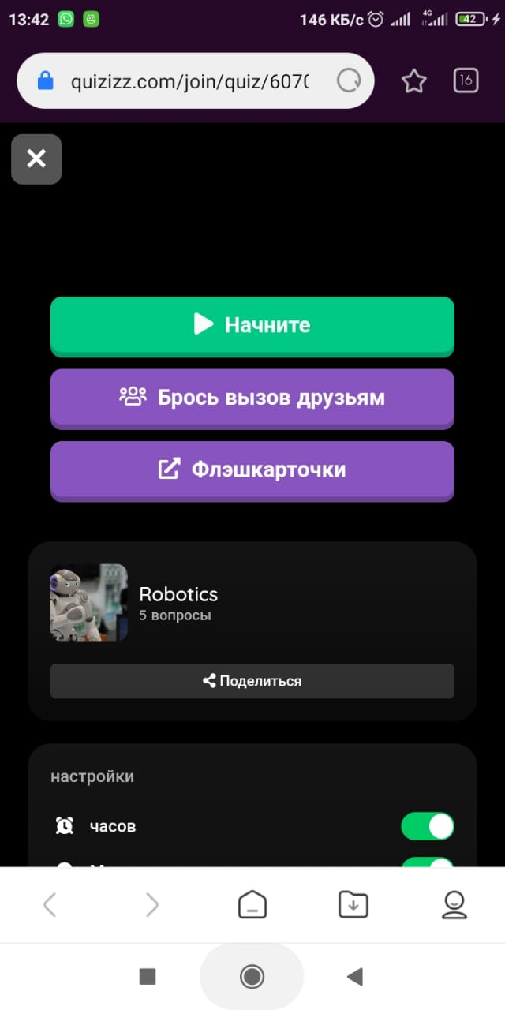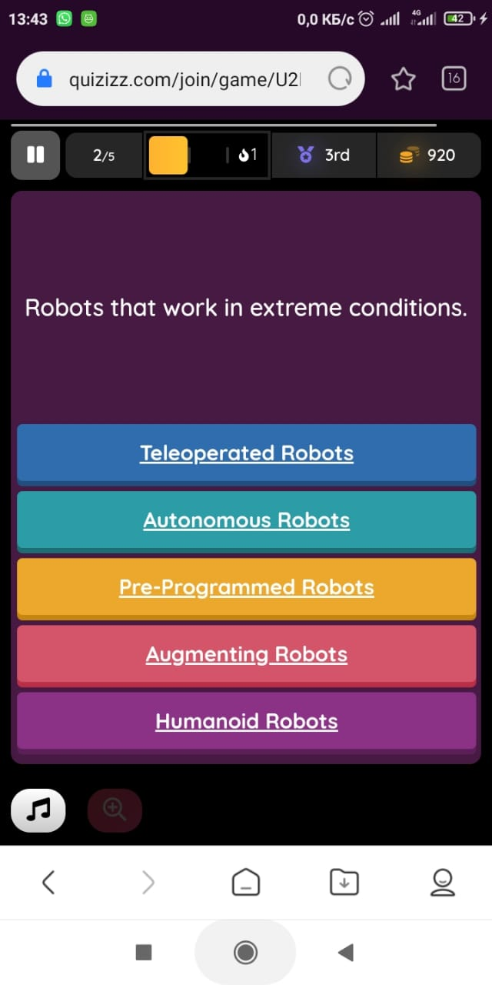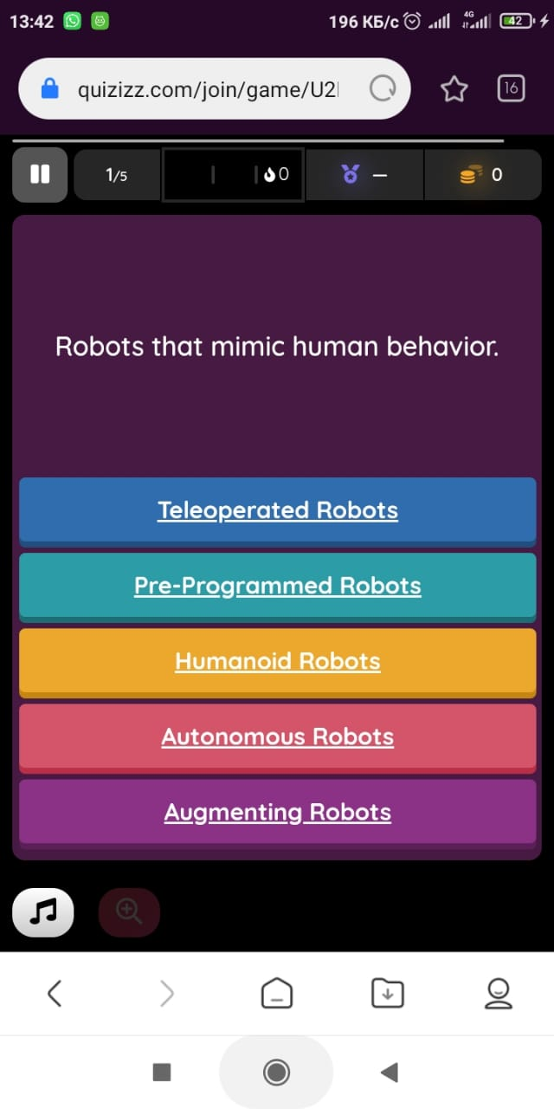

**Theme :**Genres of literature (fiction/non-fiction)

**Grade: 11**

**VOCABULARY**

***Learning new words using the site***

https://quizlet.com/_9om9kp?x=1qqt&i=2ci0qw

**1.Literary genre** - a style of expressing yourself in writing

**2.Genre-**A category or type of literature (or of art, music, etc.) characterized by a particular form, style, or content.

**3.Literature** - written works, especially those considered of superior or lasting artistic merit.

**4.Emotive** - characterized by or relating to emotion

**5.Poetry** - literary work in which special intensity is given to the expression of feelings and ideas by the use of distinctive style and rhythm; poems collectively or as a genre of literature.

**6.Drama** - a dramatic work intended for performance by actors on a stage

**7.Fiction** - a literary work based on the imagination and not necessarily on fact

**8.Nonfiction** - prose writing that is based on facts, real events, and real people, such as biography or history.

**9.Epic poem** - A long narrative poem telling of a hero's deeds

**10.Science fiction** - fiction based on imagined future scientific or technological advances and major social or environmental changes, frequently portraying space or time travel and life on other planets.

**11.Essay** -a short piece of writing on a particular subject.

**12.Literary work** - formal writing; having a marked style intended to create a particular emotional effect

**13.Classical** - of the most highly developed stage of an early civilization

**14.Symbolism** - a person, place or object which has a meaning in itself but suggests other meanings as well

**15.Realism** - the attribute of accepting the facts of life and favoring practicality and literal truth [8]

**Task 1. Checking new words by solving a crossword puzzle on the website** <https://worksheets.theteacherscorner.net/make-your-own/crossword/crossword.php>

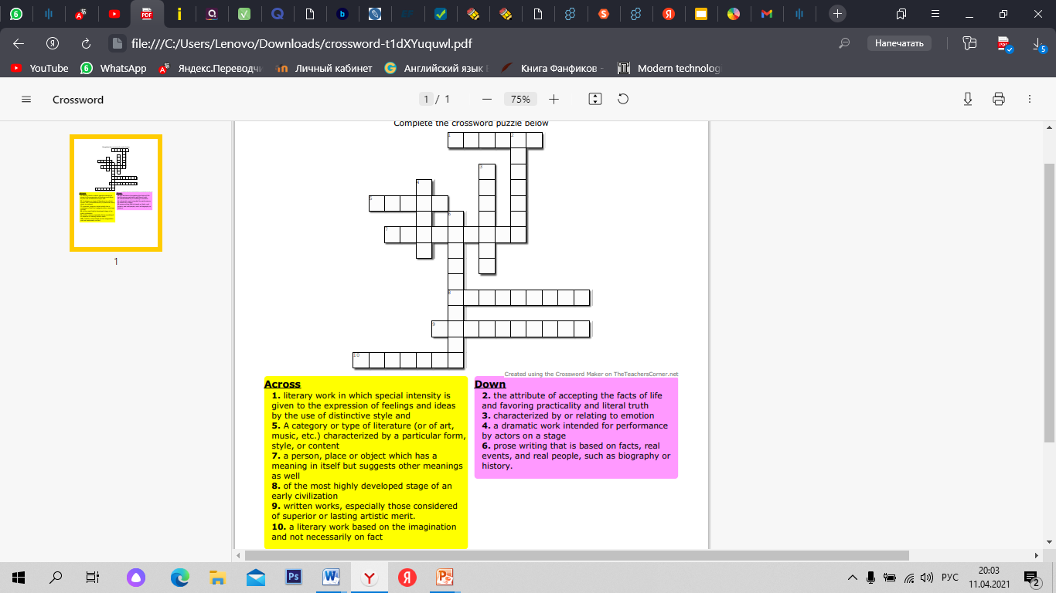

**Task 2. Watch the video. What do you know about literary genres?**

<https://www.youtube.com/watch?v=e_UE1hOh7Z0>

Video transcription :Let's talk about fiction versus nonfiction. Have you ever heard the word genre? Genre is a word we use to talk about what category a book or story fits into. In the world of books there are two main genres, fiction and nonfiction. Let's think of these two genres, like big umbrellas, all books fit under one of these two umbrellas. Let's take a look at the nonfiction umbrella first. Non-fiction books are filled with facts and information about a topic. They give true information about real people, places, things or events. In a nonfiction book, everything must be completely true and not made up. Authors write nonfiction books to teach the reader about a topic. They organize the information with text features like headings and charts. We don't have to read non-fiction books in order from beginning to end. We can go directly to the information we're looking for. Did you know that there are different types of non-fiction. Let's think of these as small umbrellas under the big non-fiction umbrella. Some of the types of nonfiction are informational, nonfiction, biography and autobiography. Now, let's take a look at the fiction umbrella. Fiction books are stories that come from an author's imagination, they are made up stories about characters or events that did not happen in real life. In a fiction book, the author can make up all sorts of things to entertain the reader. Even if there is some true information, if the book contains anything made up from the author's imagination, we call it fiction. Fiction books have important story elements like characters, plot and setting. We read fiction books in order from beginning to end so that we can understand the story. Since fiction books don't have to be completely true, authors have a lot of freedom to use their imagination. Because of this there are many different types of stories under the fiction umbrella. Some of the types of fiction are fantasy, mystery, realistic fiction, historical fiction and science fiction. Let's review what we've learned about fiction and non-fiction. Non-fiction books are filled with facts and information about a topic they are completely true and not made up at all. Authors write nonfiction books to teach and inform the reader. Fiction books are made up stories that come from an author's imagination. The stories did not happen in real life. Authors write fiction books to entertain the reader. Now, you know all about fiction and non-fiction.

**Task 3. Decide if sentences are True or False.**

***Exercises are performed using the site Socrative.com***

file:///C:/Users/Lenovo/Downloads/Quiz_Genres%20of%20literature.pdf

1.A genre is a type of book.

2.There are two main genres in the world.

3.In the non-fiction the author uses his own imagination.

4.Autobiography is a type of non-fiction

5.Fiction books should be limited to facts.

6.Mystery and fantasy are types of non-fiction.

7.Fiction books describe situations that have occurred in life.

8.Fiction books are needed to entertain the reader.

9.When writing fiction books, the important elements are the characters, and the plot.

10.Informational and nonfiction,biography are types of non-fiction.

**Answer Keys:**

1.F

2.T

3.F

4.T

5.F

6.F

7.F

8.T

9.T

10.T

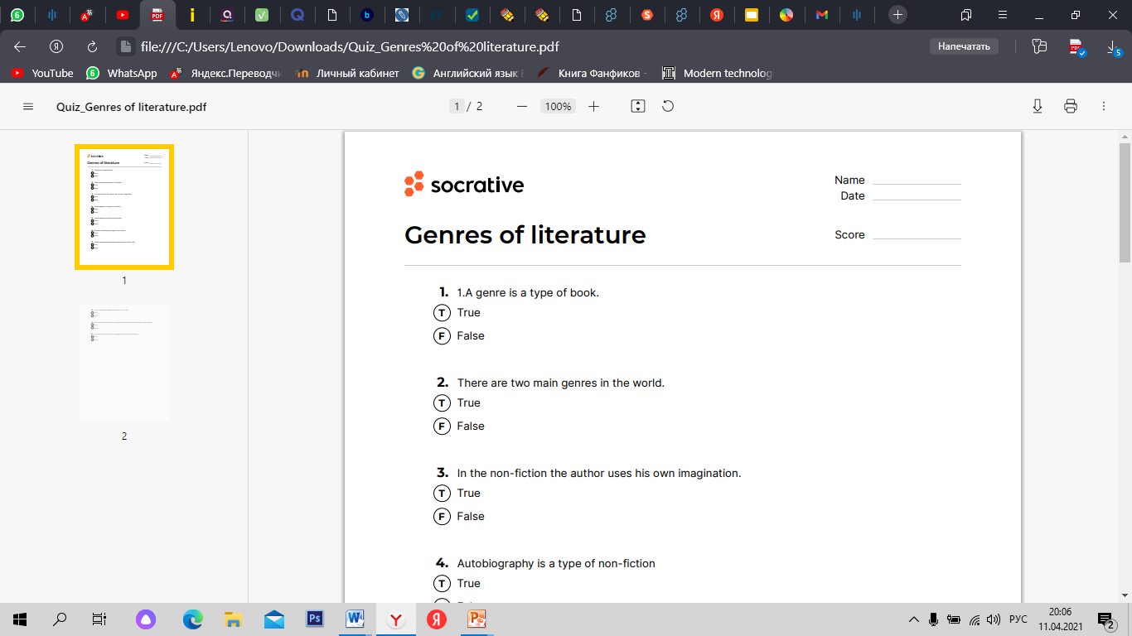

**Task 4.Read the text. Answer the questions.**

https://docs.google.com/presentation/d/13aKv-Rhrcj87vwp7XvX9PwNhuoWhvCjQ-QialYK1-Bo/edit#slide=id.p

Alice in Wonderland (By Lewis Carrol)

Alice in Wonderland by Lewis Carroll is a good example of fiction. The story narrates various adventures of the main character, Alice, in a fictitious land full of incredible creatures and events. Alice has to go through certain magical experiences in the wonderland. According to the story, one day, while reading book, Alice grows bored, and notices a white rabbit. She follows the rabbit when it goes into a hole in the ground. When peeping through the hole, Alice loses her balance and falls in. She floats down slowly into the hole, and observes everything around her. Then Alice enters Wonderland, where she witnesses a number of weird things. This entire magical tale is fabricated and imaginary, which makes it a good fiction to enjoy.

Pride and Prejudice (by Jane Austen)

Another ample example to portray fiction is, [Pride and Prejudice](https://literarydevices.net/pride-and-prejudice/) by [Jane Austen](https://literarydevices.net/jane-austen/). It is one of the most [famous](https://literarydevices.net/famous/) English novels. Unlike the previous example, this story is set in a real-life-like setting. All characters are humans, and no magical or strange events take place in this [novel](https://literarydevices.net/novel/). All of the characters, and the entire story is a made-up [narrative](https://literarydevices.net/narrative/), each element the product of Jane Austen’s imagination. She not only presents the issues of the contemporary life faced by middle class families, but also daily preoccupations of the common people. The novel presents a good fiction of actual life of nineteenth century.

Hamlet (by William Shakespeare)

William Shakespeare’s Hamlet is another apt example of fiction. The story of the play moves around the main character, Prince Hamlet. He is informed by the Ghost of his father that his uncle murdered his father, King Hamlet, and married his wife and Hamlet’s mother, Queen Gertrude. The Ghost elicits a promise from Hamlet that he will avenge his murder by killing the murderer. This becomes Hamlet’s dilemma. He vows to kill his uncle, but delays it on one pretext or another. Overall, the story is all about the intrigues and plots of the royal castle of Elsinore in Denmark. The story may have some connection with the real life events and characters, yet it is completely a fabricated story created by Shakespeare to entertain the Elizabeth audience of that time.[9]

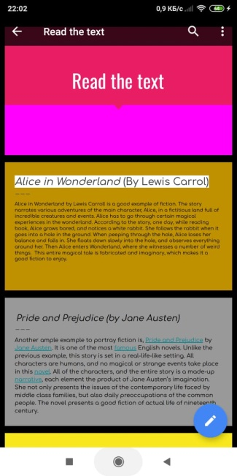

*file:///C:/Users/Lenovo/Downloads/Quiz_Answer%20the%20questions..pdf*

1. What was the name of the main character of the play "Hamlet" in Shakespeare?
2. Who is Queen Getruda?
3. Where is Elsinore Castle?
4. Who did Hamlet swear to kill?
5. What is the name of the work of Lewis Carroll?
6. What animal does Alice notice?
7. Are the events taking place in the fairy tale real?
8. Who is the author of the novel "Pride and Prejudice"
9. Which of the works describes the events taking place in the 19th century?

**Answer Keys:**

1.Hamlet

2.Hamlet’s mother

3.In Denmark

4.His uncle

5.Alice in Wonderland

6.White rabbit

7.No

8.Jane Austen

9.Pride and Prejudice

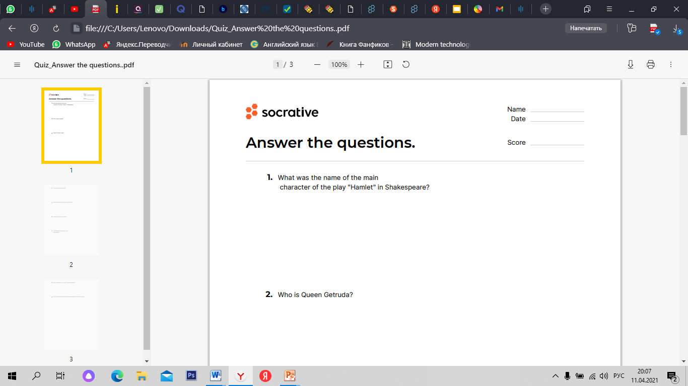

**Theme:** The world of Harry Potter

**Grade:** 11

**Task 1.Watch the video. Have you ever read or watched Harry Potter? Do you like it or not? Why? Who is your favorite character?**

<https://www.youtube.com/watch?v=yhzAytdeXgQ>

Video transcription: Albus stumbled over Minerva, McGonagall and Rubio's Hagrid professors of Hogwarts School of Witchcraft and Wizardry deliver an orphaned infant named Harry Potter to his only remaining relatives, the Dursley. Ten years later, Harry has been battling a disjointed life with the Dursley inadvertently causing an accident during a family outing and begins receiving unsolicited letters by Owles. Finally, Haggard reappears and Harry learns he is actually a wizard and has been accepted into Hogwarts against the Dursley wishes. Harry is the orphan son of two wizards who met their demise at the hands of Lord Voldemort, a malevolent, all powerful wizard by a killing curse, with Harry being the only survivor in the chaos, thus leading to his fame in the wizarding world. As the boy who lived, Harry is then taken to King's Cross station to board a train to the school. While on the train, Harry meets Ron Weasley and Hermione Granger. He also encounters Draco Malfoy, a spoiled child from a wealthy, wandering family who eventually becomes Harry's biggest rival at school. The students assemble in the Great Hall, where Harry and all the other first year students are sorted by the sorting hat between four houses Gryffindor, Huff, Puff, Raven, Claw and Slither. And Harry is placed into Gryffindor alongside Ron and Hermione. At Hogwarts, Harry begins learning wizardry and discovers more about his past and his parents. Harry is also recruited for Gryffindor Quidditch team as a seeker, which is rare for first year students. While exploring the school one night, Harry and his friends discover a giant three headed dog named Fluffy in a restricted area of the school. They later find out Fluffy is guarding the Philosopher's Stone, an item that can be used to grant its owner immortality. Harry suspects that potions teacher Severus Snape is trying to obtain the stone in order to return Voldemort to physical form. The children learn from Hagrid that Fluffy will fall asleep if he hears music. Harry, Ron and Hermione decide to try and find the stone before Snape does, but discover that Fluffy is already asleep to get past Fluffy and face a series of safeguards which include surviving a deadly plant known as Devil's Snare, a room filled with aggressive flunkies and a dangerous life sized game of chess. After getting past the tasks, Harry discovers that it was defence against the dark arts teacher, Professor Quarrell, who is trying to claim the stone and that Snape was protecting Harry. All along, Quarrell removes his turban and reveals a weak Voldemort to be living on the back of his head through an enchantment placed by Professor Dumbledore, Harry finds himself in possession of the stone. Voldemort attempts to convince Harry to give him the stone by promising to bring his parents back from the dead when Harry refuses squirrel attacks. But Harry's touch burns quarrell skin and reduces him to dust, killing him. When Harry gets back up, Voldemort Spirit rises from Corales ashes and passes through Harry, knocking him unconscious. Harry wakes up in the schools hospital wing with Dumbledore at his side. Dumbledore explains that the stone has been destroyed and that Ron and Harmony are both fine. Dumbledore also reveals how Harry was able to defeat Quarrell when Harry's mother died to save him. Her death gave Harry a love base. Protection against Voldemort. Harry, Ron and Harmony are rewarded with house points for the heroic performances, tying them for first place with slithering. However, Neville Longbottom is awarded ten points for attempting to stop his friends, giving Gryffindor enough points to win the house cup. Harry returns home for the summer. Happy to finally have a real home in Hogwarts.

**LISTENING**

**Task 2.Listen to the text. Do the exercise.**

https://listenaminute.com/h/harry_potter.html

Listening transcription : Harry Potter is a boy wizard who has taken over the world. He is everywhere. No one had heard of Harry Potter before 1997. That’s when J.K. Rowling published her first book. She’s the creator of Harry Potter. The first novel was called ‘Harry Potter and the Philosopher's Stone’ and it became an amazing success. Everyone was talking about it and Harry became an overnight phenomenon. Six more Harry Potter books followed and they all became best sellers. People went crazy over every new book. My friends waited overnight outside a bookstore to make sure they got their copy of the latest book. My friends are 40 years old! Harry Potter is now a global industry, with movies and merchandise of all kinds. It’s amazing how big he is.

Harry Potter is a boy wizard who _______________________ the world. He is everywhere. No one _______________________ Harry Potter before 1997. That’s when J.K. Rowling published her first book. She’s _______________________ Harry Potter. The first novel was called ‘Harry Potter and the Philosopher's Stone’ and _______________________ amazing success. Everyone was talking about it and Harry became an overnight phenomenon. Six more Harry Potter books _______________________ _______________________ best sellers. People _______________________ every new book. My friends waited overnight outside a bookstore _______________________ they got their copy of the latest book. My friends are 40 years old! Harry Potter _______________________ global industry, with movies and merchandise of all kinds. It’s amazing _______________________ .

**Answer Keys:**

1.has taken over

2.had heard

3.the creator of

4. it became

5.followed and they all became

6.crazy over

7.bookstore to make sure

8.is now a

9.how big he is.

**The exercise is performed using ISpringSuite 10**

**Task 3.Choose the correct answer.**

1.Who wrote the Harry Potter books?

a) Roald Dahl b) Lewis Carrol c) J.K. Rowling

2.When was the first Harry Potter book published?

a) 1997 b) 2000 b) 1995

3.What is the first book about Harry Potter called?

a) Harry Potter and the Chamber of Secrets

b) Harry Potter and the Philosopher's stone

c) Harry Potter and the Goblet of Fire

4.What are the names of Harry Potter's parents?

a) Petunia and Vernon

b) Lily and James

c) Minerva and Albus

5.What is the address of the house where Harry's aunt and uncle live?

a) 3 Hello Street

b) 10 Godric's Hollow

c) 4 Privet Drive

6.What were the people in the streets celebrating on the day described in the first chapter?

a) Hallowe'en

b) The death of You-Know-Who

c) Dumbledore's birthday

[10]

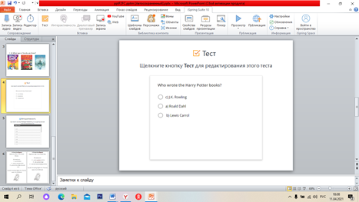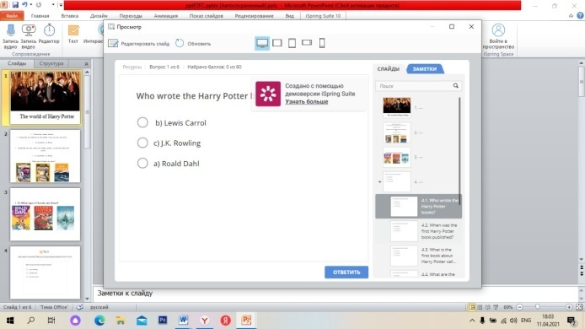

**Answer Keys:**

1.C

2.A

3.B

4.B

5.C

6.B

**The exercise is performed using ISpringSuite 10**

**Task 4. Fill the gaps.**

1.I _________(to play) with my sister in the garden.  
  
2.She_________( tosleep)in her bedroom.

3.You ­_______(to learn) Spanish thanks to Oliver.  
  
4. We _________ (to drink) a cup of tea in a nice restaurant.  
  
5.Harry _________(to study) at a magic school.  
  
6. Harryand Hermione _________ (to eat) with Ron in the canteen.  
  
7. Lord Vol de Mort  (to look for) Harry Potter.  
  
8. He  _________ (to go) to a party with his school friends.  
  
9. They _________(to watch) a movie on TV.

10.All the children _________ (to wait) for Christmas.  
  
11. July and I _________ (to make) a chocolate cake for my birthday.  
  
12. William and his cousins _________ (to listen) to music in the garage.  
  
13. Emily _________ (to wear) a blue skirt and a red blouse.  
  
14. Jenny and Paul _________(to swim) in the sea.  
  
15. I _________ (to draw) a horse.  
  
16. You _________ (phone) a wrong number !  
  
17. Marie _________ (to help) her sister in maths.  
  
18. Alain and Tom _________ (to read) an interesting story about planes.  
  
19. Kelly_________  (to tell) her parents that she wants a new computer for her birthday. [10]

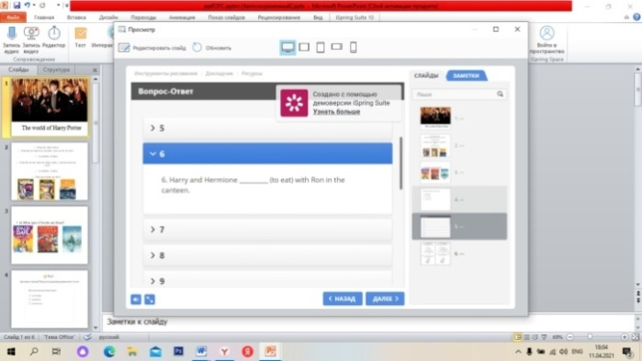

**Task 5. Fill the gaps.**

**https://docs.google.com/forms/d/e/1FAIpQLSe-OXuojVYQdH8TjFP4qpd0TEnF0mndP0Vk1cR2o0ON5htMHg/viewform**

1.If Harry __________ (kill) Voldemort, then now the world __________ a more dangerous place.

2. The Sorting Hat __________ (put) Harry in Slytherin if Harry __________ (choose) Gryffindor.

3. Dumbledore __________ (be) 136 years old today if __________ (die).

4. If I __________ (go) to Hogwarts, then the best house for me __________ (be) __________.

5. If Dumbledore __________ (kill) by Snape, then Voldemort __________ (trust) him as much.

6. If I __________ (be) at Hogwarts when Harry was there, I __________ (help) him defeat Voldemort.

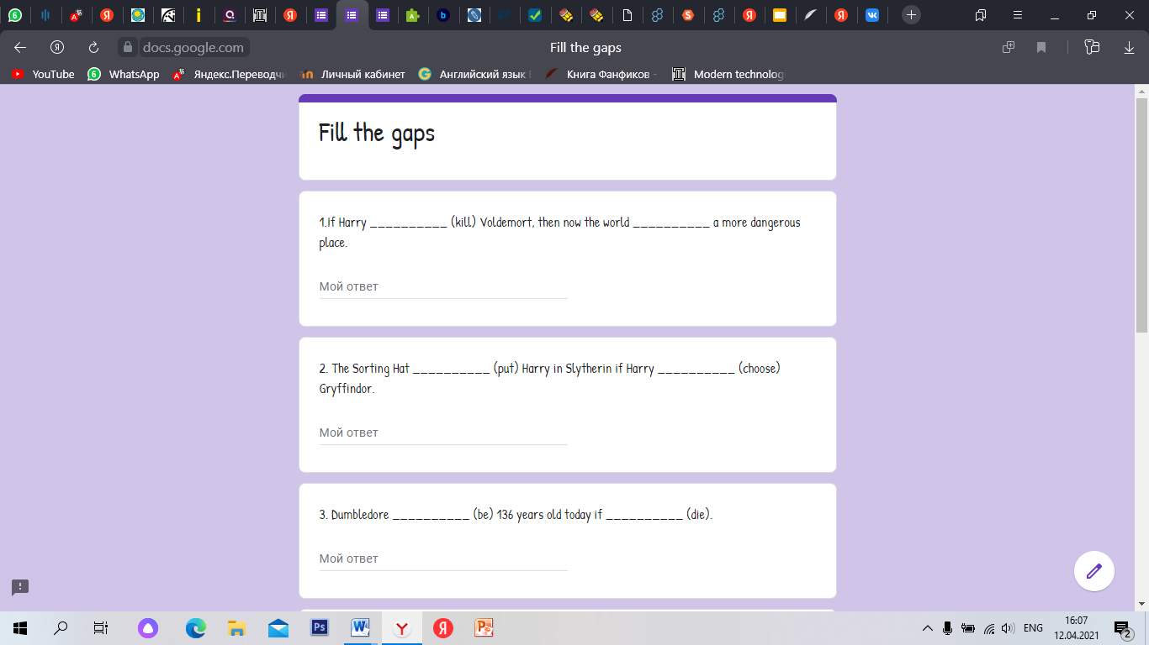

**WRITING**

**Task 6.Write a note.**

1) A note from Hogwart. Imagine you are Harry. Write a note for Hermione.

She wanted you to:

go to the library

practice a new spell with her

go out with her and Ron to buy some sweets

You didn’t do anything. Explain why. Write three reasons. Use 150-180words.

2) A note from Hogwart.Imagine you’re Ron. Write a note for Harry.

He wanted you to:

Practice quidditch with him

play a prank on Snape

steal some sweets from George and Fred

You didn’t do anything. Explain why. Write three reasons. Use 150-180 words.

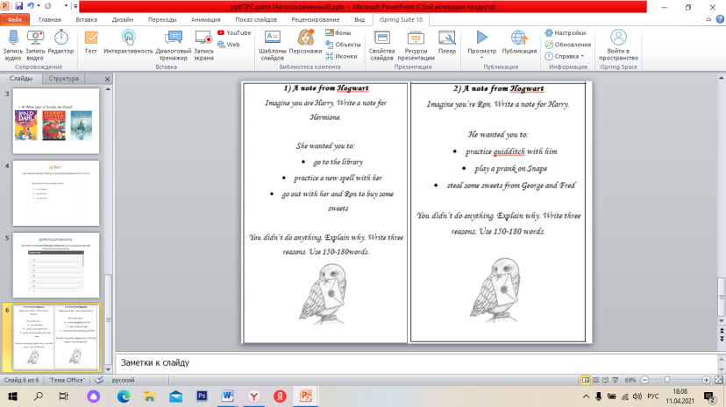

**Task 7. Write the names of the characters under the pictures below.**

<https://kahoot.it/challenge/?quiz-id=d7a92c70-0936-459c-a60f-f11c0ba61277&single-player=true>

**How to use it.**

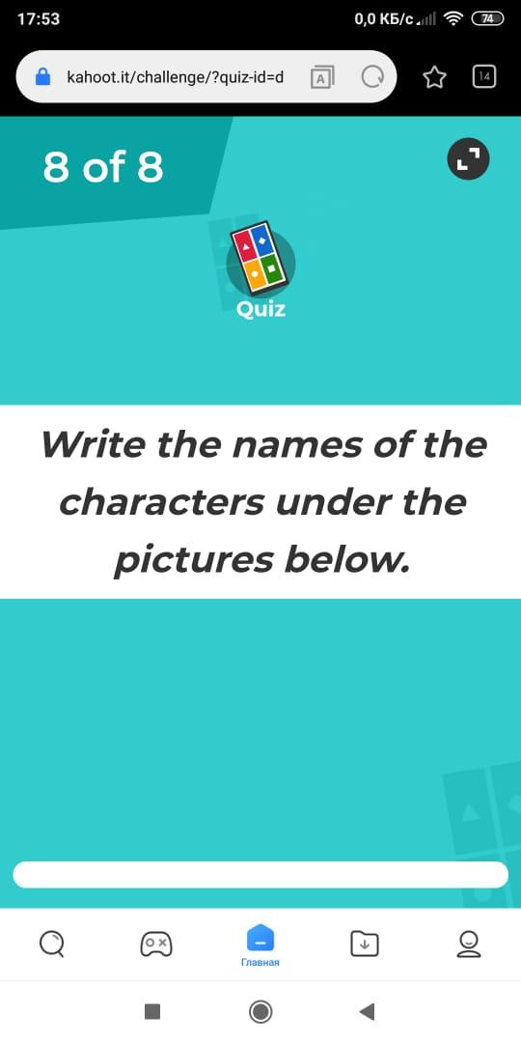

**CONCLUSION**

Modern information technologies allow us to help involve each student in the

learning process, taking into account their interests and skills. The use of new information technologies in teaching English is part of the modernization of the educational process. Thanks to this, the learning process becomes more effective and also helps to increase the motivation to learn the language.New technologies help to increase the amount of work performed and develop various skills acquired in the classroom, plan and organize an effective learning process, help to improve the communicative competence of students with the help of authentic materials, increasing interest in the use of various Internet resources, various applications for learning foreign languages, dictionaries, reference books, e-books and other information resources that can be used in the process of learning foreign languages. [16]. The most common and effective in the methodology of teaching English are resources that contain a variety of text and audio materials, video materials, dictionaries and works of authors in many languages, which help to join the foreign language culture, which help to develop the linguistic and cultural competence of students.The developed set of exercises aimed at developing the skills and abilities of using modern technologies for students is interesting and exciting. The students liked to complete the tasks and at the same time use new technologies, which increased their interest in learning the language .These tests and personal observations allow us to conclude that English as an academic subject becomes the most effective through the use of modern technologies, the use of the set of exercises developed by us contributes to improving the skills of using new technologies and is a good motivational factor for improving the level of English language proficiency.

Methodological recommendations:

1) When applied to English lessons, it is better to use the exercises in a complex.

2) It is most effective to use a set of exercises to cover all types of speech activity.

3) You need to be able to build the learning process so that students can listen to the statements of their classmates, be able to solve problems, express their opinion and prove it.

As mentioned earlier, the problem with the use of modern information

technologies in English lessons has not yet been solved. This is due to the lack of technical support for some schools, as well as the lack of skills and abilities of teachers to use these technologies in their lessons.

The practical result of the second chapter can be used as a training material in

preparation for the Unified National Exam in English.

**REFERENCES**

1.N.A.Nazarbayev.Address by the President of the Republic of Kazakhstan [Electronic source.] / N.Nazarbayev / -Electronic text data.- “Strategy Kazakhstan-2050”

Access mode: <http://www.akorda.kz>

2.Computer [Electronic source.] / -Electronic text data.-

Access mode: <https://www.computerhope.com/jargon/c/computer.htm>

3.What Is an Electronic Textbook? [Electronic source.] / -Electronic text data.-

Access mode: <https://www.wisegeek.net/what-is-an-electronic-textbook.htm>

4.Инновационные технологии в обучении иностранному языку / [Electronic source.] / -Electronic text data.-

Access mode: <https://urok.1sept.ru/articles/566297>]

5.Войтко, С.А. Об использовании информационно-коммуникационных технологий на уроках английского языка [Электронный ресурс] / -Электрон.текстовые дан. - Интернет-журнал Фестиваль педагогических идей «Открытый урок», 2004 – 2005.

Режим доступа:  <http://festival.1september.ru/articles/415914/>

6.What is nanotechnology? /[Electronic source.] / -Electronic text data.-

Access mode: <https://studfiles.net/preview/2968310/>

7.What Is Robotics? [Electronic source.] / -Electronic text data.-

Access mode: <https://builtin.com/robotics>

8.Literature Vocabulary List / [Electronic source.] / -Electronic text data.-

Access mode: <https://www.vocabulary.com/lists/39652>

9.Examples of Fiction in Literature /[Electronic source.] / -Electronic text data.-

Access mode: <https://literarydevices.net/fiction/>

10."Harry Potter and the Philosopher's Stone" by J.K. Rowling (reading and comprehension tasks) [Electronic source.] / -Electronic text data.-

Access mode: https://infourok.ru/arry-potter-and-te-pilosopers-stone-by-k-roling-reading-and-compreension-tasks-3119537

11.Zakharova I. G. Information technologies in education: Textbook for students of higher educational institutions [Text] / Zakharova I.G. - Moscow: Akadamiya, 2007.- p.14

12.Ефременко В.А. Применение информационных технологий на уроках иностранного языка [Текст] / Ефременко В.А. – ИЯШ – 2007. - №8 – 18 с.

13.«Использование ИКТ на уроках английского языка на второй ступени обучения» /[Электронный ресурс] / -Электрон.текстовые дан. - Режим доступа:

<https://nsportal.ru/shkola/inostrannye-yazyki/library/2012/09/09/primenenie-informatsionno-kommunikatsionnykh>

14. Синегубова Н. М. Информационные технологии на уроках английского языка [Текст] / Синегубова Н.М. - Школа. – 2006. - № 2. – с. 43-44

15. Кочергина И.Г Совершенствование познавательных способностей учащихся через использование информационно-коммуникативных технологий в обучении английскому языку. [Текст] / Кочергина И.Г. - Иностранные языки в школе – 2009. - №3

16. Gower R. Teaching practice: Handbook for teachers in training. [Text] / Gower R., Philips D., Walters S. - Macmillan, 2007. - p.113-117.

17. Варшауэр М., Интернет для обучения английскому: Рекомендации для преподавателей [Текст] / Варшауэр М., Уиттекер Ф. – Кембридж : Изд-во Кембриджского университета. – 2007. – с. 119–127.

18. Afanasyeva N.A., Information and communication technologies in teaching a foreign language [Electronic source] / N.A.Afanasyeva/ -Electronic text data.- 2009. -N 2.

Access mode: https://scienceforum.ru/2019/article/2018010691

19. Никитина И.Н. Урок английского языка с использованием новых информационных технологий [Электронный ресурс] / - Электрон.текстовые дан. - Интернет-журнал Фестиваль педагогических идей «Открытый урок», 2004 – 2005./

Режим доступа: http://festival.1september.ru/articles/213950 /.

20. Воевода Е. В. Интернет-технологии в обучении иностранным языкам [Текст] / Воевода Е.В - Высшее образование в России. – 2009. – № 9. – с. 110–114.

21. William R.V. Computer in school. [Text] / William R.V., Mackley C. - Oxford University Press, 2000 - p.38.

22. Use of internet resources in foreign language lessons. [Electronic source.] / -Electronic text data.- Access mode: <https://scienceforum.ru/2019/article/2018010691>

23. Кристалл Д. Язык и Интернет.[Текст] / Кристалл Д. – Вып. 2-й. – Кембридж: Изд-во Кембриджского университета, 2006. – с. 12–18.

24. Полат Е. С. Интернет на уроках иностранного языка [Текст] / Полат Е. - Иностранные языки в школе. – 2005. – № 2. – с. 13

25.Соколова Э. Я. Анализ потенциала интернет-ресурсов в обучении иностранному языку [Электронный ресурс] / - Электрон.текстовые дан.- Международный журнал прикладных и фундаментальных исследований. – 2015. – № 5–4. – с. 607– 610.

Режим доступа: https://applied-research.ru/ru/article/view?Id=7179.